LOUISA ST (COUNTY RD 9) Block 1
Block 25
BLOCK PLAN CREEMORE COMMONS473-536 Units
Block 2 STREET L
Block
Block
26
27
STREET H
Block 29
Part of Lots 8 & 9 Concession 4 Township of Clearview, County of Simcoe
Phase 1a
Block 3
Block 5
B
^{lock 28 -} D^{2.}0
Future Development 1.688ha (4.17ac)
F
a
i
r
g
N
r
o
_{County} _{Rd} 9
NELSON ST
Existing Park
Block
0.856ha (2.11ac)
4
STREET B (NELSON ST)
Block
30
STREET G
^{67ha (5.11ac})
^{rainag}e
^{und}s
R
_{Lou}i_{sa} _{S}t
d
_{Edward} _{St} E
C
o
C
o
u
n
t
y

R
d

4
2
Block 15
Block 10
Phase 1a
Block
Block
32
31
Block
Block
S
l
l
i
n
g
_{Con} _{Rd} 5
w
o
o
d

S
t
Key Map - Creemore 1 : 50,000
Block
6
Block 11
Block
Block
17
16
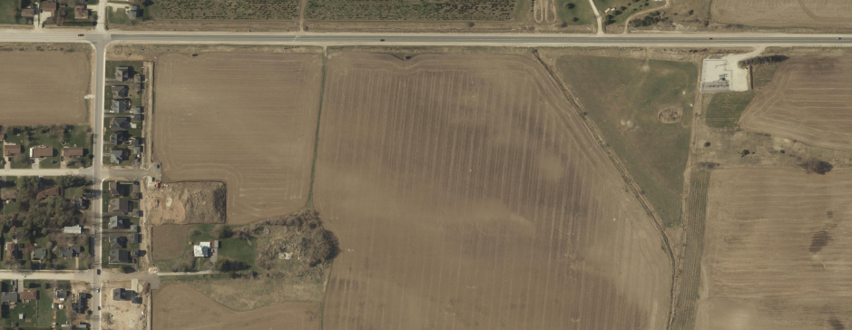
T
33
34
R
E
E
T

Block
G
35
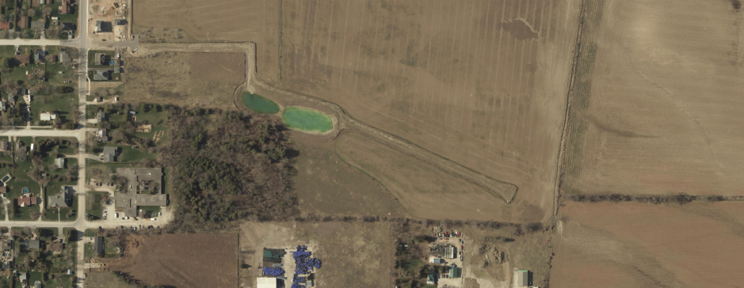
BLOCK | TYPE/FRONTAGE | MIN. YIELD | MAX. YIELD
1 | OS
2 | 6.1m to 15.2m |  | 32 55
3 | 15.2m |  | 2 2
4 | 6.1m to 11.6m |  | 4 8
5 | 9.1m to 15.2m |  | 1010
6 | 11.6m to 15.2m |  | 66
7 | 15.2m | 6 | 6
8 | 11.6m to 15.2m |  | 8  8
9 | Park
10 | 11.6m to 15.2m |  | 99
11 | 11.6m to 15.2m | 1 | 8
12 | 9.1m to 11.6m |  | 8  8
13 | 9.1m to 11.6m |  | 8  8
14 | 11.6m to 15.2m | 5 | 5
15 | 11.6m to 15.2m |  | 66
16 | 9.1m to 11.6m |  | 1616
17 | 9.1m to 11.6m |  | 1616
18 | 9.1m to 11.6m |  | 66
19 | 9.1m to 11.6m |  | 1818
20 | 11.6m to 15.2m |  | 1616
21 | 9.1m to 11.6m |  | 66
22 | 9.1m to 15.2m |  | 1919
23 | 8.5m |  | 68 68
24 | 9.1m to 11.6m |  | 13  13
25 | OS
26 | 15.2m | 2 | 2
27 | 11.6m to 15.2m | 17 | 17
28 | Drainage
29 | 6.1m to 15.2m |  | 027
30 | 11.6m to 15.2m | 4 | 4
31 | 11.6m | 11 | 11
32 | 11.6m to 15.2m | 13 | 13
33 | 9.1m to 15.2m | 9 | 9
34 | 9.1m to 15.2m | 7 | 7
35 | 9.1m to 11.6m |  | 1010
36 | 9.1m to 11.6m | 18 | 18
37 | 9.1m to 11.6m | 18 | 18
38 | 9.1m to 11.6m |  | 12  12
39 | 9.1m to 15.2m |  | 12  12
40 | 15.2m | 14 | 14
41 | 11.6m to 15.2m | 11 | 11
42 | 9.1m to 11.6m | 12 | 12
43 | 11.6m |  | 02
44 | 11.6m to 15.2m | 11 | 11
45 | 15.2m |  | 99
46 | SWM
TOTAL473536

LEGEND

WELLINGTON ST

STREET _{J} STREET I
S
S
S
S
T
T
T
T
R
R
R
R
Block
H

Block T

Phase 1 Residential
Phase 2 Residential

Phase 3 (Future Development)
M
E
E
T
Phase 1a
Block
E
E
E
E
12
13
T
T

E
Block
Block
E
T
19
20

E
39
E

R
T
Parks & Open Space
Block
A
D
E
R
7
Y

S
S
F
A
Block40

Stormwater Management
T
Block 14
Block 18 Block 21 Block
Block

38
Blocks

FRANCIS ST

STREET C (FRANCIS ST)
Block

37
36

Block 41
Potential Pumping Station
CAROLINE ST
Block 8
Phase 1a
Block 9
Park
0.133ha (0.33ac)
Existing Park
Block 22

STREET K

S
T
Block 46
1.685ha (4.16ac)
Block 23
R
E
2.549ha
E
T
(6.30ac)

Block
SWM 2.036ha (5.03ac)

Block
Block
Block
G
24
42
44
45

Note: This drawing is for discussion purposes only.
Sources: 51M-1163, J.D. Barnes Limited, January 17, 2019.

County of Simcoe interactive map.
0 20 40 60 80 100 120m

Block

43

ELIZABETH ST

N
Scale: 1 : 3,000
Temporary Turning Basin

Drawn By: A.M. Date: April 4, 2023

85 Bayfield Street, Unit 300, Barrie, Ontario, L4M 3A7
T: 705 797 8977 C: 705 730 8850
celeste PHILLIPS
celeste@cplan.ca
PLANNING INC.

